Project- Target SQL

Submitted by Mr Marshal Harsh Mathew

Data set- Target , Brazil

Synopsis

Data analysis based on the data set from Target to derive valuable insights on the sale, customer behavior etc. Based on the data we are trying to find the trends in different aspects by using Bigquery.

This project is divided into different categories and in each category different queries are used to get insights

**Category 1**

Import the dataset and do usual exploratory analysis steps like checking the structure & characteristics of the dataset

1.Data type of columns in a table

Query

1. select
2. *
3. from `Bigquery_project_marsh050223`.INFORMATION_SCHEMA.COLUMNS;

Result

|  |  |  |  |
| --- | --- | --- | --- |
| table_schema | table_name | column_name | ordinal_position |
| Bigquery_project_marsh050223 | customers | customer_id | 1 |
| Bigquery_project_marsh050223 | customers | customer_unique_id | 2 |
| Bigquery_project_marsh050223 | customers | customer_zip_code_prefix | 3 |
| Bigquery_project_marsh050223 | customers | customer_city | 4 |
| Bigquery_project_marsh050223 | customers | customer_state | 5 |
| Bigquery_project_marsh050223 | geolocations | geolocation_zip_code_prefix | 1 |
| Bigquery_project_marsh050223 | geolocations | geolocation_lat | 2 |
| Bigquery_project_marsh050223 | geolocations | geolocation_lng | 3 |
| Bigquery_project_marsh050223 | geolocations | geolocation_city | 4 |
| Bigquery_project_marsh050223 | geolocations | geolocation_state | 5 |
| Bigquery_project_marsh050223 | order_items | order_id | 1 |
| Bigquery_project_marsh050223 | order_items | order_item_id | 2 |
| Bigquery_project_marsh050223 | order_items | product_id | 3 |
| Bigquery_project_marsh050223 | order_items | seller_id | 4 |
| Bigquery_project_marsh050223 | order_items | shipping_limit_date | 5 |
| Bigquery_project_marsh050223 | order_items | price | 6 |
| Bigquery_project_marsh050223 | order_items | freight_value | 7 |
| Bigquery_project_marsh050223 | order_reviews | review_id | 1 |
| Bigquery_project_marsh050223 | order_reviews | order_id | 2 |
| Bigquery_project_marsh050223 | order_reviews | review_score | 3 |
| Bigquery_project_marsh050223 | order_reviews | review_comment_title | 4 |
| Bigquery_project_marsh050223 | order_reviews | review_creation_date | 5 |
| Bigquery_project_marsh050223 | order_reviews | review_answer_timestamp | 6 |
| Bigquery_project_marsh050223 | Orders | order_id | 1 |
| Bigquery_project_marsh050223 | Orders | customer_id | 2 |
| Bigquery_project_marsh050223 | Orders | order_status | 3 |
| Bigquery_project_marsh050223 | Orders | order_purchase_timestamp | 4 |
| Bigquery_project_marsh050223 | Orders | order_approved_at | 5 |
| Bigquery_project_marsh050223 | Orders | order_delivered_carrier_date | 6 |
| Bigquery_project_marsh050223 | Orders | order_delivered_customer_date | 7 |
| Bigquery_project_marsh050223 | Orders | order_estimated_delivery_date | 8 |
| Bigquery_project_marsh050223 | payments | order_id | 1 |
| Bigquery_project_marsh050223 | payments | payment_sequential | 2 |
| Bigquery_project_marsh050223 | payments | payment_type | 3 |
| Bigquery_project_marsh050223 | payments | payment_installments | 4 |
| Bigquery_project_marsh050223 | payments | payment_value | 5 |
| Bigquery_project_marsh050223 | products | product_id | 1 |
| Bigquery_project_marsh050223 | products | product_category | 2 |
| Bigquery_project_marsh050223 | products | product_name_length | 3 |
| Bigquery_project_marsh050223 | products | product_description_length | 4 |
| Bigquery_project_marsh050223 | products | product_photos_qty | 5 |
| Bigquery_project_marsh050223 | products | product_weight_g | 6 |
| Bigquery_project_marsh050223 | products | product_length_cm | 7 |
| Bigquery_project_marsh050223 | products | product_height_cm | 8 |
| Bigquery_project_marsh050223 | products | product_width_cm | 9 |
| Bigquery_project_marsh050223 | Sellers | seller_id | 1 |
| Bigquery_project_marsh050223 | Sellers | seller_zip_code_prefix | 2 |
| Bigquery_project_marsh050223 | Sellers | seller_city | 3 |
| Bigquery_project_marsh050223 | Sellers | seller_state | 4 |

Insight

The data is stored in different columns and the primary keys like order_id, customer_id, product_id, seller_id, state_id will help in joining tables to get the insigts

2.Time period of orders

**Query**

1. select
2. min(order_purchase_timestamp) as initial_order,
3. max(order_purchase_timestamp) as final_order
4. from`Bigquery_project_marsh050223.orders`;

Result

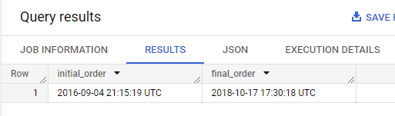

3.Time period of order delivery to customer

Query

1. select
2. min(order_delivered_customer_date) as initial_delivery,
3. max(order_delivered_customer_date) as final_delivery
4. from`Bigquery_project_marsh050223.orders`;

Result

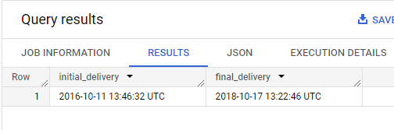

Time period of reviews

The data table was wrong in capturing the date .The year, date and month columns got interchanged which is corrected in the below query

**Query**

1. select
2. min(date_act) as Starting_date,
3. max(date_act) as Final_date
4. from(
5. select
6. date((t.day_new),t.month_new,t.year_new) as date_act
7. from
8. (
9. select
10. extract(day from review_answer_timestamp)+2000 as day_new,
11. extract(month from review_answer_timestamp) as month_new,
12. extract(year from review_answer_timestamp) as year_new
13. from `Bigquery_project_marsh050223.order_reviews`
14. order by year_new desc)t
15. )

Result

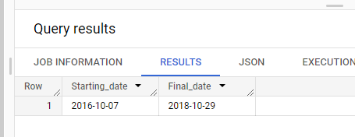

Cities and States of customers ordered during the given period

Query

select

customer_city as City,

customer_state as State

from `Bigquery_project_marsh050223.customers`

group by customer_city,customer_state

order by customer_city;

Result

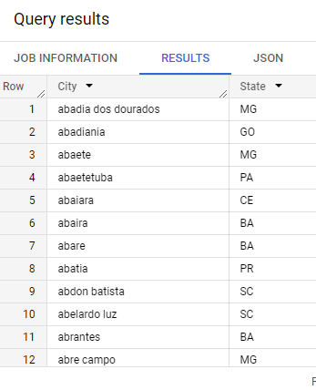

Insights

Time periods are slights different in tables but the data is mainly from 2016 September to 2018 October.

**Category 2**

In-depth Exploration:

1. Is there a growing trend on e-commerce in Brazil? How can we describe a complete scenario? Can we see some seasonality with peaks at specific months?

A.The growth of e commerce in the given period of time ( year on year)

Query

select

distinct t.Year_of_Sale,

round(sum(t.price) over(partition by t.Year_of_Sale)) as Total_revenue_in_USD,

round(sum(t.Price_with_shipping) over(partition by t.Year_of_Sale)) as Total_revenue_with_shipping_cost_in_USD

from

(select

*,

extract(year from od.order_purchase_timestamp) as Year_of_Sale,

extract(month from od.order_purchase_timestamp) as Month_of_Sale,

ore.price+ore.freight_value as Price_with_shipping

from `Bigquery_project_marsh050223.orders` od left join `Bigquery_project_marsh050223.order_items` ore

                                                          on od.order_id=ore.order_id

                                              left join`Bigquery_project_marsh050223.customers` cr  on od.

                                                          customer_id=cr.customer_id

)t

order by t.Year_of_Sale;

Result

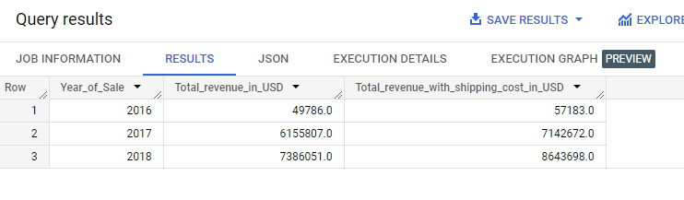

Insight

The sale is increasing year by year as per the given data set. The e commerce is booming as per the data, so more customers will be opting for online sale. We need to forecast the demand and more sellers need to be introduced to the e commerce business.

B. Cumulative Sale- MOM

Query

select

distinct t.Year_of_Sale,

t.Month_of_Sale,

round(sum(t.price) over(partition by t.Year_of_Sale order by t.Month_of_Sale range between unbounded preceding and current row)) as Cumulative_Sale

from

(select

*,

extract(year from od.order_purchase_timestamp) as Year_of_Sale,

extract(month from od.order_purchase_timestamp) as Month_of_Sale,

ore.price+ore.freight_value as Price_with_shipping,

extract(time from od.order_purchase_timestamp) as Order_time

from `Bigquery_project_marsh050223.orders` od left join `Bigquery_project_marsh050223.order_items` ore

                                                          on od.order_id=ore.order_id

                                              left join`Bigquery_project_marsh050223.customers` cr  on od.

                                                          customer_id=cr.customer_id

)t

order by t.Year_of_Sale,t.Month_of_Sale;

Result

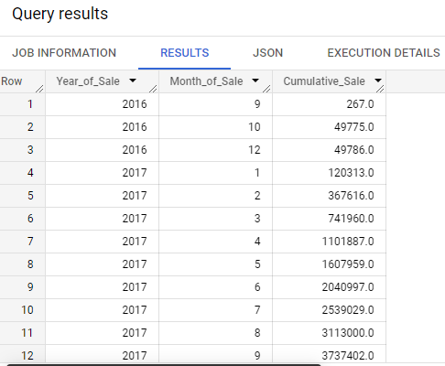

C. Peak months of Sale

Query

select

*

from

(

select

distinct t.Year_of_Sale,

t.Month_of_Sale,

round(sum(t.price) over(partition by t.Year_of_Sale,T.Month_of_Sale)) as Sum_price

from

(select

*,

extract(year from od.order_purchase_timestamp) as Year_of_Sale,

extract(month from od.order_purchase_timestamp) as Month_of_Sale,

ore.price+ore.freight_value as Price_with_shipping,

extract(time from od.order_purchase_timestamp) as Order_time

from `Bigquery_project_marsh050223.orders` od left join `Bigquery_project_marsh050223.order_items` ore

                                                          on od.order_id=ore.order_id

                                              left join`Bigquery_project_marsh050223.customers` cr  on od.

                                                          customer_id=cr.customer_id

)t

)

order by Sum_price desc

Result

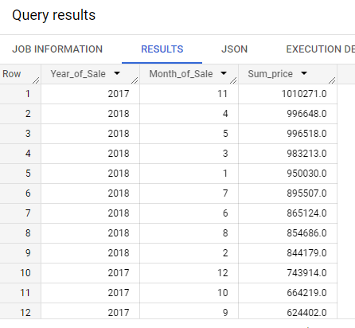

The Peak month is 2017 November, thanks giving festival and starting of summer in Brazil might be the reason of increase in Sale.

**Category 3**

Evolution of E-commerce orders in the Brazil region:

1.Get month on month orders by states

Query

select

distinct t.customer_state as State,

t.Year_of_Sale as Year,

t.Month_of_Sale as Month,

count(distinct t.order_id) over(partition by t.Year_of_Sale,t.Month_of_Sale,t.customer_state) as MOM_orders

from

(

select

od.order_id,

cr.customer_unique_id,

cr.customer_state,

extract(year from od.order_purchase_timestamp) as Year_of_Sale,

extract(month from od.order_purchase_timestamp) as Month_of_Sale,

ore.price+ore.freight_value as Price_with_shipping,

extract(time from od.order_purchase_timestamp) as Order_time,

od.order_purchase_timestamp,

min(od.order_purchase_timestamp)over (partition by cr.customer_unique_id order by od.order_purchase_timestamp rows between unbounded preceding and unbounded following) as First_order_date

from `Bigquery_project_marsh050223.orders` od left join `Bigquery_project_marsh050223.order_items` ore

                                                          on od.order_id=ore.order_id

                                              left join`Bigquery_project_marsh050223.customers` cr  on od.

                                                          customer_id=cr.customer_id

where lower(od.order_status)!='canceled'

)t

order by 1,2,3;

Result

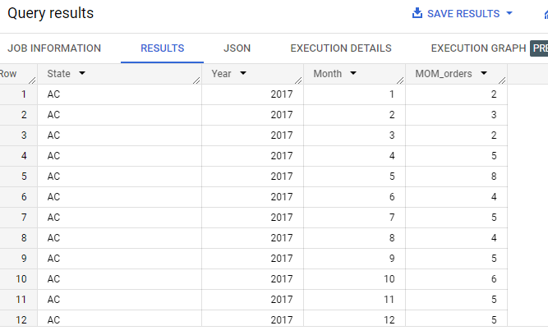

2.What time do Brazilian customers tend to buy (Dawn, Morning, Afternoon or Night)?

Query

select

t.Purchase_time_Brazil_std_time,

count(distinct t.order_id) as Orders_placed

from(

select

order_id,

order_purchase_timestamp,

case when time_sub(TIME (extract(time from order_purchase_timestamp)), interval 3 HOUR) between '03:00:00' and '07:00:00' then'Dawn '

when time_sub(TIME (extract(time from order_purchase_timestamp)), interval 3 HOUR) between '07:00:01' and '11:59:59' then 'Morning'

when time_sub(TIME (extract(time from order_purchase_timestamp)), interval 3 HOUR) between '12:00:00' and '18:00:00' then 'After_noon'

else 'Night'

end as Purchase_time_Brazil_std_time

from `Bigquery_project_marsh050223.orders`

where lower(order_status)!="canceled"

order by order_purchase_timestamp desc

)t

group by t.Purchase_time_Brazil_std_time

order by count(distinct order_id) desc;

Result

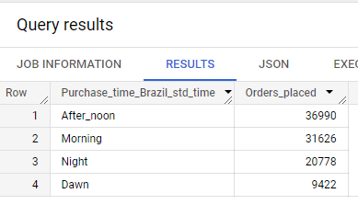

Insight

We have calculated the orders based on the Brazilia timing which is 3 hours behind UTC.The customers are placing orders mainly during afternoon and morning. So during these timing more adds need to played on the app/ or other available screens which may push the sale up.

**Category 4**

Impact on Economy: Analyze the money movement by e-commerce by looking at order prices, freight and others.

1. Get % increase in cost of orders from 2017 to 2018 (include months between Jan to Aug only) - You can use “payment_value” column in payments table

Query

SELECT

round(((Next_year-Cost_of_Order) *100/cost_of_order)) as Percentage_of_increase_in_sale

from

(

select

Year,

Cost_of_Order,

lead(Cost_of_order)over(order by Year) as Next_Year

from

(

select

distinct t.Year,

round(sum(t.payment_value)) as Cost_of_order

from

(

select

p.order_id,

o.order_status,

extract(year from o.order_purchase_timestamp) as Year,

extract(month from o.order_purchase_timestamp) as Month,

p.payment_value

from `Bigquery_project_marsh050223.payments` p  left join `Bigquery_project_marsh050223.orders` o

                                                      on p.order_id=o.order_id

)t

where t.order_status!='canceled' and t.Year in (2017,2018) and t.Month between 1 and 8

group by t.year

))

limit 1;

Result

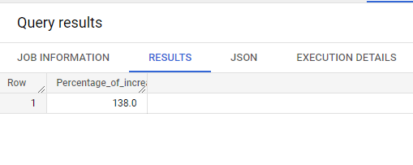

1. Mean & Sum of price and freight value by customer state

Query

select

distinct t.customer_state as State,

round(avg(t.price)over(partition by t.customer_state)) as Mean_price,

round(avg(t.freight_value)over(partition by t.customer_state)) as Mean_freight,

round(sum(t.price)over(partition by t.customer_state)) as Sum_price,

round(sum(t.freight_value)over(partition by t.customer_state)) as Sum_freight,

from

(

select

distinct od.order_id,

cr.customer_state,

sum(ore.freight_value) as freight_value,

sum(ore.price) as price,

from `Bigquery_project_marsh050223.orders` od left join `Bigquery_project_marsh050223.order_items` ore

                                                          on od.order_id=ore.order_id

                                              left join`Bigquery_project_marsh050223.customers` cr  on od.

                                                          customer_id=cr.customer_id

where lower(od.order_status)!='canceled'

group by od.order_id, cr.customer_state

)t

order by Mean_freight desc;

Result

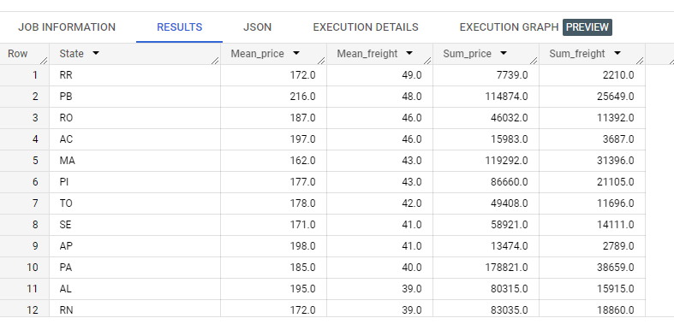

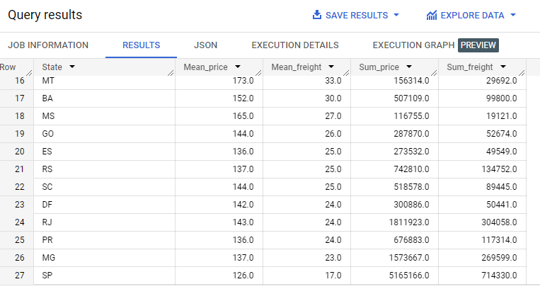

Insight

The freight cost is more in RR which is the state Roraima and state PB , which is the state Paraiba which are respectively the northernmost and easternmost states of Brazil.The RR state is full of Amzon rain forest and high terrain so transportation cost is more and the state PB is also very far from the main The least cost of freight is at Sao polo, the financial capital of brazil.

When we look at the seller details based on the orders,

Query

select

distinct seller_id,

count_products,

seller_state

from

(

select

count(product_id) over (partition by seller_id) as count_products,

seller_id,

seller_state

from

(

select

distinct o.order_id,

o.product_id,

o.seller_id,

s.seller_state,

from `Bigquery_project_marsh050223.order_items` o inner join`Bigquery_project_marsh050223.sellers` s

                                          on o.seller_id=s.seller_id

)

)

order by count_products desc

Result

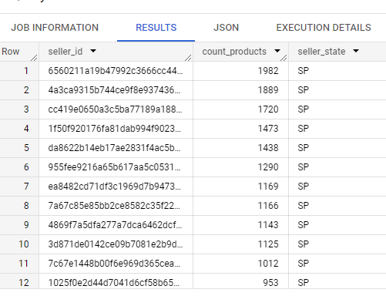

Checking the sellers from state RR and PB

Query

select

distinct seller_id,

count_products,

seller_state

from

(

select

count(product_id) over (partition by seller_id) as count_products,

seller_id,

seller_state

from

(

select

distinct o.order_id,

o.product_id,

o.seller_id,

s.seller_state,

from `Bigquery_project_marsh050223.order_items` o inner join`Bigquery_project_marsh050223.sellers` s

                                          on o.seller_id=s.seller_id

)

)

where seller_state in ('RR','PB')

Result

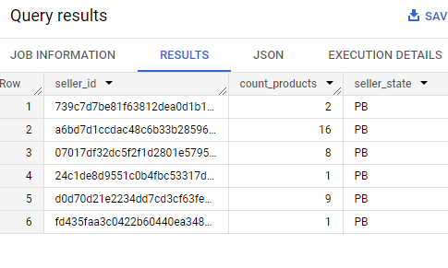

The top selling sellers are based out of SP , so the average freight cost is lesser. Only six sellers are from PB and there are no sellers from RR which is the reason for the high average freight costs which indicates customer from these states are mainly buying from sellers from other states. So Target should try to find some sellers is RR, PB or nearby states which might bring down the freight cost to these states.

Map of Brazil

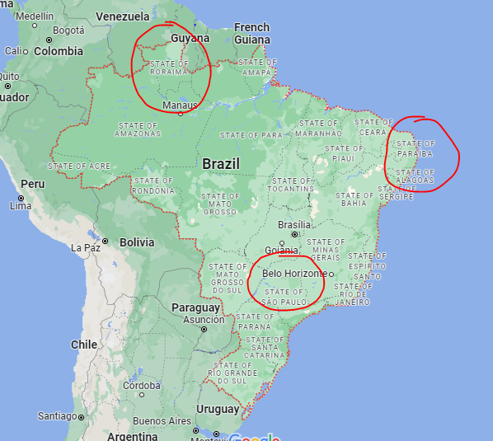

**Category 5**

Analysis on sales, freight and delivery time

1.Calculate days between purchasing, delivering and estimated delivery

Query

select

order_id,

date_diff(order_estimated_delivery_date,order_purchase_timestamp,day) as Diff_est_order,

date_diff(order_delivered_customer_date,order_purchase_timestamp,day) as time_to_delivery,

date_diff(order_estimated_delivery_date,order_delivered_customer_date,day) as Diff_estimated_delivery,

date_diff(order_delivered_customer_date,order_delivered_carrier_date,day) as Diff_car_cus

from `Bigquery_project_marsh050223.orders`

Result

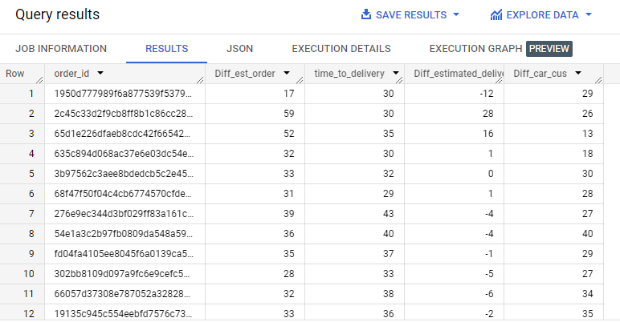

2.Find time_to_delivery & diff_estimated_delivery. Formula for the same given below:

time_to_delivery = order_delivered_customer_date-order_purchase_timestamp

diff_estimated_delivery = order_estimated_delivery_date-order_delivered_customer_date

Query

select

order_id,

date_diff(order_delivered_customer_date,order_purchase_timestamp,day) as time_to_delivery,

date_diff(order_estimated_delivery_date,order_delivered_customer_date,day) as Diff_estimated_delivery,

from `Bigquery_project_marsh050223.orders`

Result

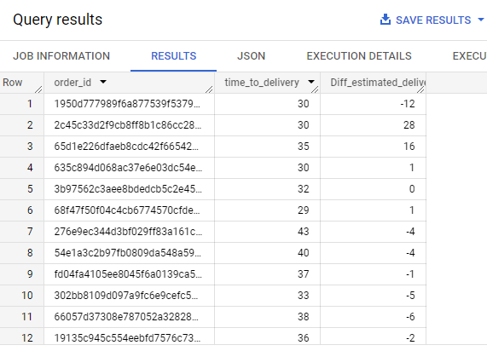

Query

select

round(countif(Diff_estimated_delivery<0)*100/count(order_id),2) as percentage_delayed_orders

from

(

select

order_id,

date_diff(order_delivered_customer_date,order_purchase_timestamp,day) as time_to_delivery,

date_diff(order_estimated_delivery_date,order_delivered_customer_date,day) as Diff_estimated_delivery,

from `Bigquery_project_marsh050223.orders`

where date_diff(order_estimated_delivery_date,order_delivered_customer_date,day) is not null

)

Result

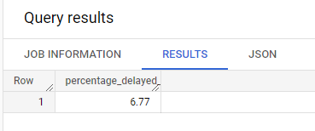

Insights

6.77% of the orders got delivered after the estimated time which needs to come down.

3.Group data by state, take mean of freight_value, time_to_delivery, diff_estimated_delivery

Query

select

customer_state,

round(avg(fre_val),2) as avg_fr,

round(avg(time_to_delivery),2) as avg_timedel,

round(avg(Diff_estimated_delivery),2) as avg_diff_estdel,

from

(

select

distinct order_id,

sum(freight_value) over (partition by order_id) as fre_val,

customer_state,

time_to_delivery,

Diff_estimated_delivery

from

(

select

o.order_id,

t.freight_value,

c.customer_state,

date_diff(o.order_delivered_customer_date,o.order_purchase_timestamp,day) as time_to_delivery,

date_diff(o.order_estimated_delivery_date,o.order_delivered_customer_date,day) as Diff_estimated_delivery,

from `Bigquery_project_marsh050223.orders` o left join `Bigquery_project_marsh050223.order_items` t on

                                                  o.order_id=t.order_id

                                              left join `Bigquery_project_marsh050223.customers`c on

                                                  o.customer_id=c.customer_id

))

group by customer_state

Result

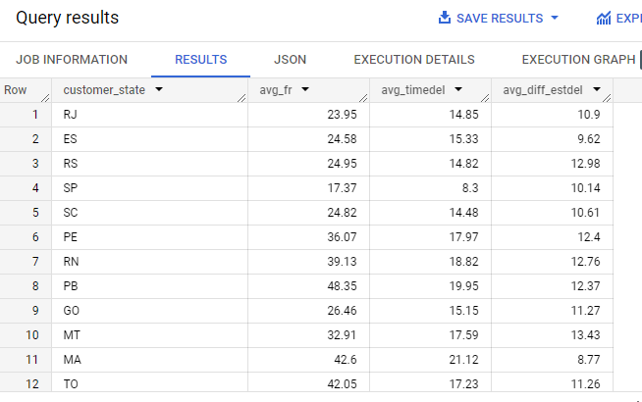

4. Sort the data to get the following:

1. Top 5 states with highest/lowest average freight value - sort in desc/asc limit 5

Query- lowest 5 states

select

customer_state,

round(avg(fre_val),2) as avg_fr,

#round(avg(time_to_delivery),2) as avg_timedel,

#round(avg(Diff_estimated_delivery),2) as avg_diff_estdel,

from

(

select

distinct order_id,

sum(freight_value) over (partition by order_id) as fre_val,

customer_state,

time_to_delivery,

Diff_estimated_delivery

from

(

select

o.order_id,

t.freight_value,

c.customer_state,

date_diff(o.order_delivered_customer_date,o.order_purchase_timestamp,day) as time_to_delivery,

date_diff(o.order_estimated_delivery_date,o.order_delivered_customer_date,day) as Diff_estimated_delivery,

from `Bigquery_project_marsh050223.orders` o left join `Bigquery_project_marsh050223.order_items` t on

                                                  o.order_id=t.order_id

                                              left join `Bigquery_project_marsh050223.customers`c on

                                                  o.customer_id=c.customer_id

))

group by customer_state

order by avg(fre_val)

limit 5;

Result

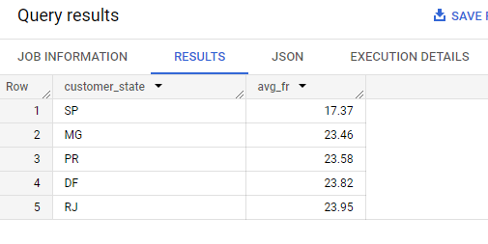

Query – Top 5 States

select

customer_state,

round(avg(fre_val),2) as avg_fr,

#round(avg(time_to_delivery),2) as avg_timedel,

#round(avg(Diff_estimated_delivery),2) as avg_diff_estdel,

from

(

select

distinct order_id,

sum(freight_value) over (partition by order_id) as fre_val,

customer_state,

time_to_delivery,

Diff_estimated_delivery

from

(

select

o.order_id,

t.freight_value,

c.customer_state,

date_diff(o.order_delivered_customer_date,o.order_purchase_timestamp,day) as time_to_delivery,

date_diff(o.order_estimated_delivery_date,o.order_delivered_customer_date,day) as Diff_estimated_delivery,

from `Bigquery_project_marsh050223.orders` o left join `Bigquery_project_marsh050223.order_items` t on

                                                  o.order_id=t.order_id

                                              left join `Bigquery_project_marsh050223.customers`c on

                                                  o.customer_id=c.customer_id

))

group by customer_state

order by avg(fre_val) desc

limit 5;

Result

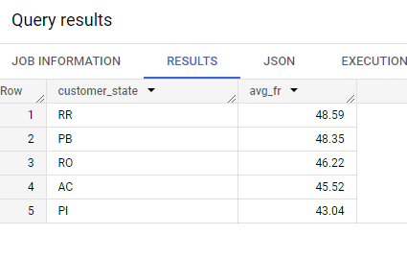

Top 5 states with highest/lowest average time to delivery

Query – lowest five states

select

customer_state,

#round(avg(fre_val),2) as avg_fr,

round(avg(time_to_delivery),2) as avg_timedel,

#round(avg(Diff_estimated_delivery),2) as avg_diff_estdel,

from

(

select

distinct order_id,

sum(freight_value) over (partition by order_id) as fre_val,

customer_state,

time_to_delivery,

Diff_estimated_delivery

from

(

select

o.order_id,

t.freight_value,

c.customer_state,

date_diff(o.order_delivered_customer_date,o.order_purchase_timestamp,day) as time_to_delivery,

date_diff(o.order_estimated_delivery_date,o.order_delivered_customer_date,day) as Diff_estimated_delivery,

from `Bigquery_project_marsh050223.orders` o left join `Bigquery_project_marsh050223.order_items` t on

                                                  o.order_id=t.order_id

                                              left join `Bigquery_project_marsh050223.customers`c on

                                                  o.customer_id=c.customer_id

))

group by customer_state

order by avg(time_to_delivery)

limit 5;

Result

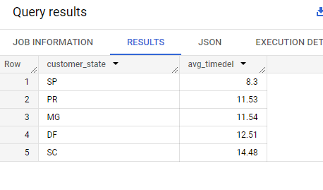

Query top five states

select

customer_state,

#round(avg(fre_val),2) as avg_fr,

round(avg(time_to_delivery),2) as avg_timedel,

#round(avg(Diff_estimated_delivery),2) as avg_diff_estdel,

from

(

select

distinct order_id,

sum(freight_value) over (partition by order_id) as fre_val,

customer_state,

time_to_delivery,

Diff_estimated_delivery

from

(

select

o.order_id,

t.freight_value,

c.customer_state,

date_diff(o.order_delivered_customer_date,o.order_purchase_timestamp,day) as time_to_delivery,

date_diff(o.order_estimated_delivery_date,o.order_delivered_customer_date,day) as Diff_estimated_delivery,

from `Bigquery_project_marsh050223.orders` o left join `Bigquery_project_marsh050223.order_items` t on

                                                  o.order_id=t.order_id

                                              left join `Bigquery_project_marsh050223.customers`c on

                                                  o.customer_id=c.customer_id

))

group by customer_state

order by avg(time_to_delivery) desc

limit 5;

Result

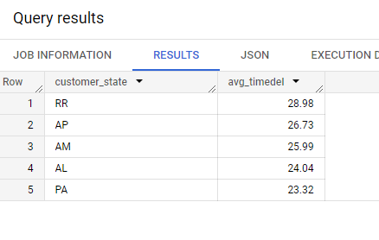

Top 5 states where delivery is really fast/ not so fast compared to estimated date

Query top 5 states with fastest delivery compared to estimated delivery

select

customer_state,

#round(avg(fre_val),2) as avg_fr,

#round(avg(time_to_delivery),2) as avg_timedel,

round(avg(Diff_estimated_delivery),2) as avg_diff_estdel,

from

(

select

distinct order_id,

sum(freight_value) over (partition by order_id) as fre_val,

customer_state,

time_to_delivery,

Diff_estimated_delivery

from

(

select

o.order_id,

t.freight_value,

c.customer_state,

date_diff(o.order_delivered_customer_date,o.order_purchase_timestamp,day) as time_to_delivery,

date_diff(o.order_estimated_delivery_date,o.order_delivered_customer_date,day) as Diff_estimated_delivery,

from `Bigquery_project_marsh050223.orders` o left join `Bigquery_project_marsh050223.order_items` t on

                                                  o.order_id=t.order_id

                                              left join `Bigquery_project_marsh050223.customers`c on

                                                  o.customer_id=c.customer_id

))

group by customer_state

order by avg(Diff_estimated_delivery) desc

limit 5;

Result

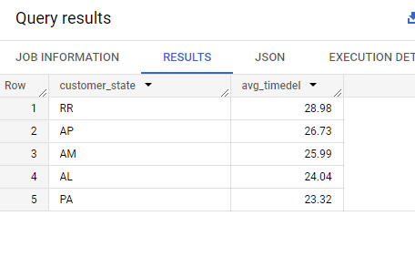

Query -five states with lowest delivery time compared to estimated delivery

select

customer_state,

#round(avg(fre_val),2) as avg_fr,

#round(avg(time_to_delivery),2) as avg_timedel,

round(avg(Diff_estimated_delivery),2) as avg_diff_estdel,

from

(

select

distinct order_id,

sum(freight_value) over (partition by order_id) as fre_val,

customer_state,

time_to_delivery,

Diff_estimated_delivery

from

(

select

o.order_id,

t.freight_value,

c.customer_state,

date_diff(o.order_delivered_customer_date,o.order_purchase_timestamp,day) as time_to_delivery,

date_diff(o.order_estimated_delivery_date,o.order_delivered_customer_date,day) as Diff_estimated_delivery,

from `Bigquery_project_marsh050223.orders` o left join `Bigquery_project_marsh050223.order_items` t on

                                                  o.order_id=t.order_id

                                              left join `Bigquery_project_marsh050223.customers`c on

                                                  o.customer_id=c.customer_id

))

group by customer_state

order by avg(Diff_estimated_delivery)

limit 5;

Result

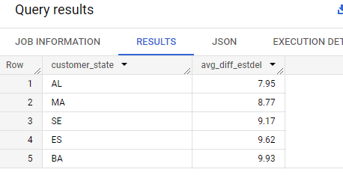

**Category 6 Payment Type Analysis**

1.Month over Month count of orders for different payment types

Query:

select

Year,

Month,

Payment_type,

count(order_id) as Count_orders,

from

(

select

extract(year from order_purchase_timestamp) as Year,

extract(month from order_purchase_timestamp) as Month,

order_id,

case when UPI>0 and Voucher>0 and credit_card>0 and debit_card>0 then "all"

     when UPI>0 and Voucher>0 and credit_card>0 and debit_card=0 then 'UPI+VOUCHER+CREDIT_CARD'

     when UPI>0 and Voucher>0 and credit_card=0 and debit_card>0 then 'UPI+VOUCHER+CREDIT_CARD'

     when UPI>0 and Voucher=0 and credit_card>0 and debit_card>0 then 'UPI+CREDIT_CARD+DEBIT_CARD'

     when UPI=0 and Voucher>0 and credit_card>0 and debit_card>0 then 'VOUCHER+CREDIT_CARD+DEBIT_CARD'

     when UPI>0 and Voucher>0 and credit_card=0 and debit_card=0 then 'UPI+VOUCHER'

     when UPI>0 and Voucher=0 and credit_card>0 and debit_card=0 then 'UPI+CREDIT_CARD'

     when UPI>0 and Voucher=0 and credit_card=0 and debit_card>0 then 'UPI+DEBIT_CARD'

     when UPI=0 and Voucher>0 and credit_card>0 and debit_card=0 then 'VOUCHER+CREDIT_CARD'

     when UPI=0 and Voucher>0 and credit_card=0 and debit_card>0 then 'VOUCHER+DEBIT_CARD'

     when UPI=0 and Voucher=0 and credit_card>0 and debit_card>0 then 'DEBIT_CARD+CREDIT_CARD'

     when UPI>0 and Voucher=0 and credit_card=0 and debit_card=0 then 'UPI'

     when UPI=0 and Voucher>0 and credit_card=0 and debit_card=0 then 'VOUCHER'

     when UPI=0 and Voucher=0 and credit_card>0 and debit_card=0 then 'CREDIT_CARD'

     when UPI=0 and Voucher=0 and credit_card=0 and debit_card>0 then 'DEBIT_CARD'

     ELSE 'NA'

     END AS PAYMENT_TYPE

     from

     (

select

order_id,

order_purchase_timestamp,

sum(UPI) as UPI,

sum(Voucher) as Voucher,

sum(credit_card) as credit_card,

sum(debit_card) as debit_card,

sum(not_defined) as not_define_new

from(

select

p.order_id,

o.order_purchase_timestamp,

case when lower(p.payment_type)="upi" then 1 else 0 end as UPI,

case when lower(p.payment_type)="voucher" then 1 else 0 end as Voucher,

case when lower(p.payment_type)="credit_card" then 1 else 0 end as credit_card,

case when lower(p.payment_type)="debit_card" then 1 else 0 end as debit_card,

case when lower(p.payment_type)="not_defined" then 1 else 0 end as not_defined,

from `Bigquery_project_marsh050223.payments` p left join `Bigquery_project_marsh050223.orders` o on p.order_id=o.order_id

)

group by order_id,order_purchase_timestamp

     )

)   group by Year,Month,payment_type

order by Year,Month,payment_type;

Result

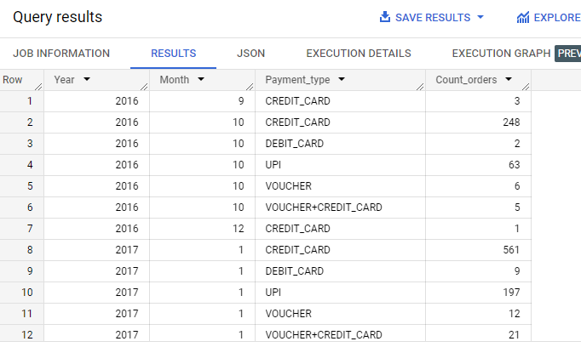

Insights:

Credit card is the most popular payment option in the given period of time followed by the UPI. Three cases are there where payment type in not defined and a few customers used multiple payment options together to complete the transaction.

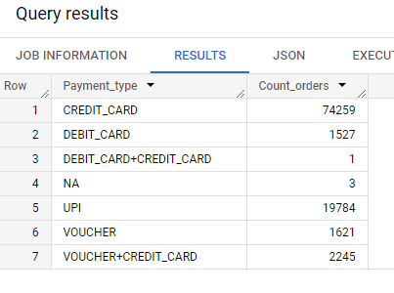

2.Count of orders based on the no. of payment installments

Query

select

distinct payment_installments,

count(order_id) as count_orders

from

(

select

order_id,

payment_installments,

nos,

max_install

from(

select

order_id,

payment_installments,

nos,

max(nos) over(partition by order_id) as max_install

from(

select

order_id,

payment_installments,

row_number()over(partition by order_id) as nos

from `Bigquery_project_marsh050223.payments`

)

)

where nos=max_install

)

group by payment_installments

order by payment_installments

Result

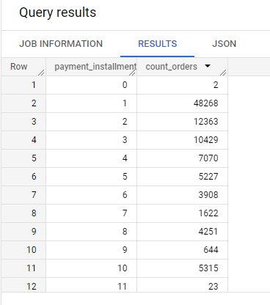

Fast moving products in the given time period

Query

select

*

from

(

select

distinct product_id,

product_category,

count(order_item_id) over(partition by product_id) as count_of_products

from

(

SELECT

o.order_id,

o.order_item_id,

o.product_id,

p.product_category,

p.product_name_length

from `Bigquery_project_marsh050223.order_items` o left join `Bigquery_project_marsh050223.products` p

                                                on o.product_id=p.product_id

)

)

order by count_of_products desc;

Result

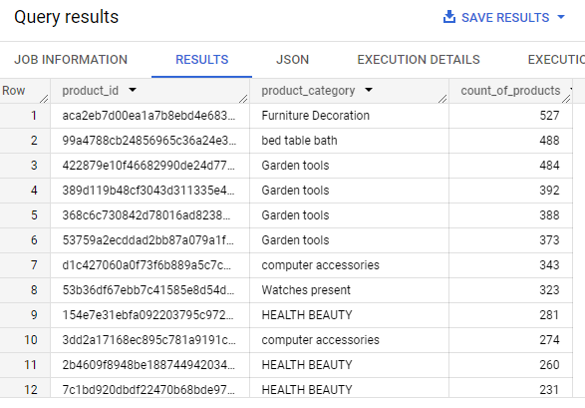

Seller with avg review less than 2

Query

select

*

from

(

select

distinct seller_id,

round(avg(review_score)over(partition by seller_id),2) as avg_review

from

(

select

o.order_id,

ot.product_id,

ov.review_score,

ot.seller_id

from `Bigquery_project_marsh050223.orders` o left join `Bigquery_project_marsh050223.order_reviews`  ov on o.order_id=ov.order_id

                                             left join `Bigquery_project_marsh050223.order_items` ot on

                                             o.order_id=ot.order_id

where review_score is not null

)

)

where avg_review <2

Result

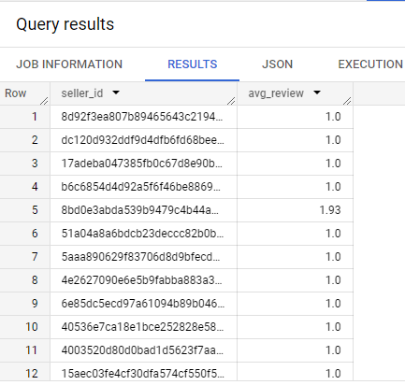

Suggestions

* E commerce is booming in Brazil from 2017 , so more products need to be introduced to the business.
* More sellers need to introduce in farthest places or nearby places to reduce the freight cost.
* Need to revisit the list of sellers with lower rating and check on the reason , then need to work on improving it.
* Need to improve the delivery of the products with in the estimated time , for which the current percentage is only 93%.
* Customers are mainly using credit card as payment option and also using the EMI option. So need to associate with all major banks to give credit card offers to customers so that more customers will go for sale.
* Need to plan well before the peak months like November by storing more products.